# **Case Study Questions**

**1. Enterprise Relationship Diagram**

**Using the following DDL schema details to create an ERD for all the Clique Bait datasets.**

### **2. Digital Analysis**

**Using the available datasets - answer the following questions using a single query for each one:**

1. **How many users are there?**

1. **How many cookies does each user have on average?**

1. **What is the unique number of visits by all users per month?**

1. **What is the number of events for each event type?**

1. **What is the percentage of visits which have a purchase event?**

1. **What is the percentage of visits which view the checkout page but do not have a purchase event?**

1. **What are the top 3 pages by number of views?**

1. **What is the number of views and cart adding for each product category?**

1. **What are the top 3 products by purchases?**

### **3. Product Funnel Analysis**

**Using a single SQL query - create a new output table which has the following details:**

* **How many times was each product viewed?**

**How many times was each product added to cart?**

* **How many times was each product added to a cart but not purchased (abandoned)?**
* **How many times was each product purchased?**

**Additionally, create another table which further aggregates the data for the above points but this time for each product category instead of individual products.**

**Use your 2 new output tables - answer the following questions:**

1. **Which product had the most views, cart adds and purchases?**

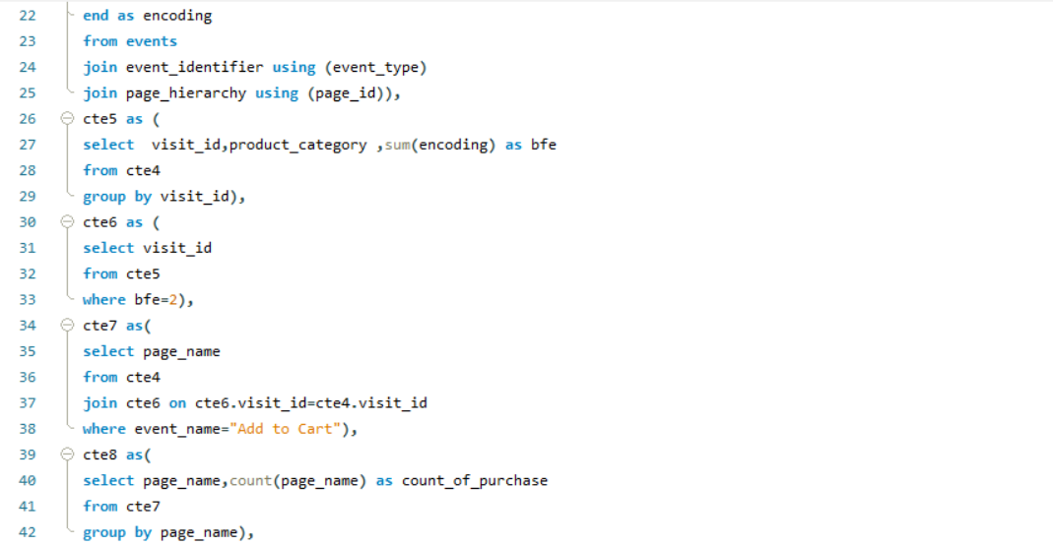

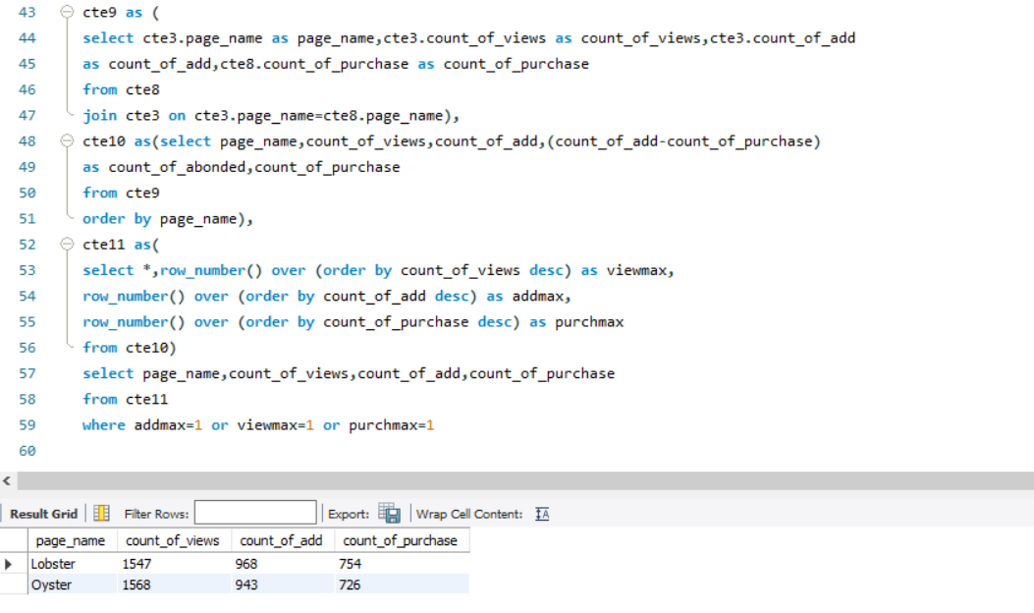

1. **Which product was most likely to be abandoned?**

1. **Which product had the highest view to purchase percentage?**

1. **What is the average conversion rate from view to cart add?**

1. **What is the average conversion rate from cart add to purchase?**

